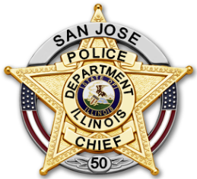
San Jose Police Department

311 S. 2nd St., P.O. Box 257, San Jose, Illinois 62682
309-247-1234 Office 309-247-3530 Fax

April 30, 2021

To Whom It May Concern:

The population of San Jose, located in Mason and Logan Counties, was approximately 670. Five (5) officers, including the chief position, were employed during the period. The department utilized five (5) Pro-Vision BC-300 Bodycams. During the year one (1) Bodycam became defective and was replaced under warranty.

The department utilized the Law Enforcement Training and Standards Board’s Guidelines and Model Rules for Body-Worn Cameras (BWC).

No BWC recordings during the grant period were utilized in prosecutions, civil proceedings or internal investigations.

