**Section 930.ILLUSTRATION B Filter Valving**

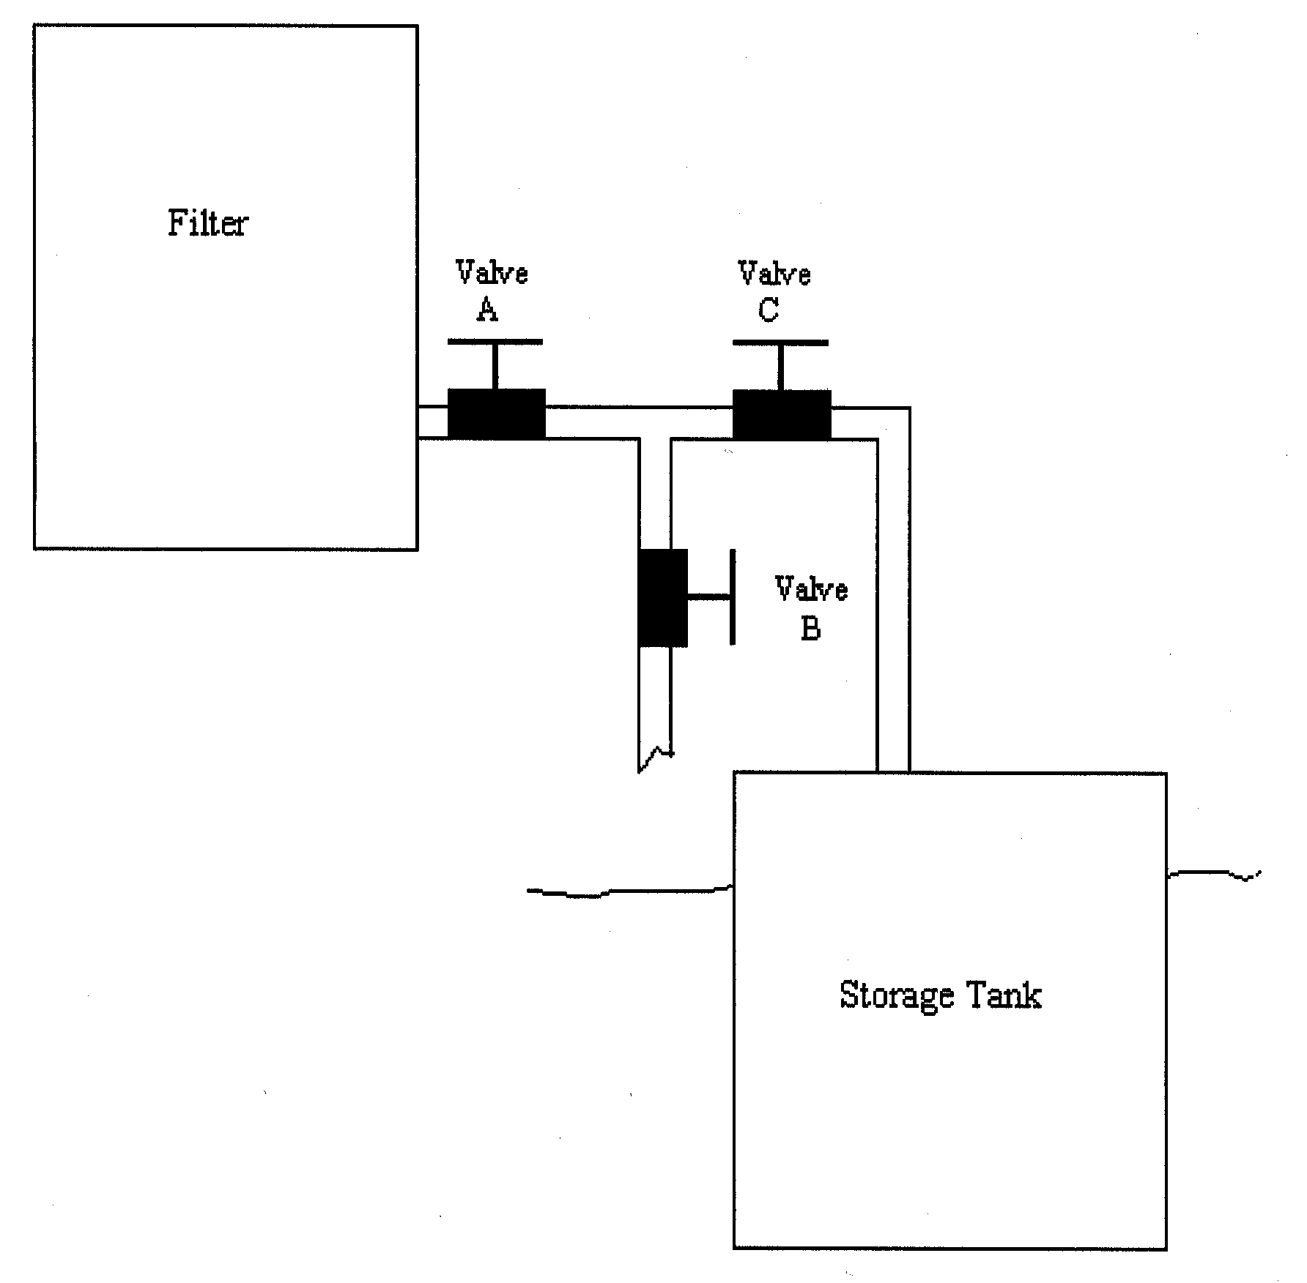

(Source: Amended at 27 Ill. Reg. 15998, effective October 1, 2003)