**Section 890.APPENDIX K Illustrations for Subpart K**

**Section 890.ILLUSTRATION Z Dual Branches** <br> **Section 890.ILLUSTRATION AA Right and Wrong Vent Connections<br> Section 890.ILLUSTRATION BB Fixtures Back-to-Back in Battery<br> Section 890.ILLUSTRATION CC Fixture Connections-Offset Vents<br> Section 890.ILLUSTRATION DD Circuit Vented Fixtures<br> Section 890.ILLUSTRATION EE Vent Stacks<br> Section 890.ILLUSTRATION FF Combination Waste and Vent<br> Section 890.ILLUSTRATION GG Special Venting for Island Fixtures**

(Referenced in Section 890.1520(b))

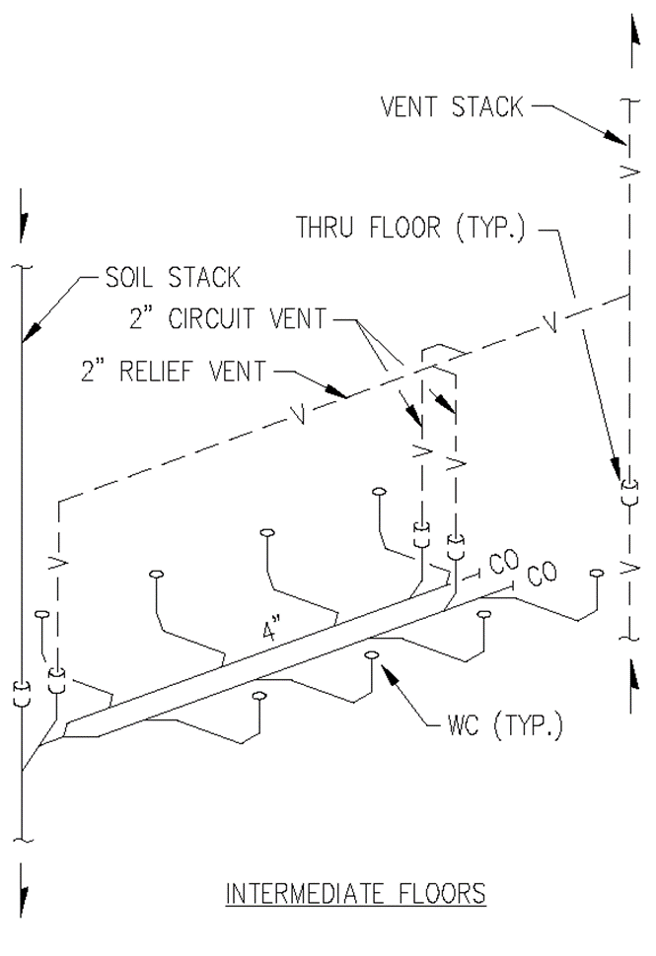

(Source: Amended at 38 Ill. Reg. 9940, effective April 24, 2014)

**Section 890.APPENDIX K Illustrations for Subpart K**

**Section 890.ILLUSTRATION AA Right and Wrong Vent Connections**

(Referenced in Sections 890.1450(b) and 890.1520(c))

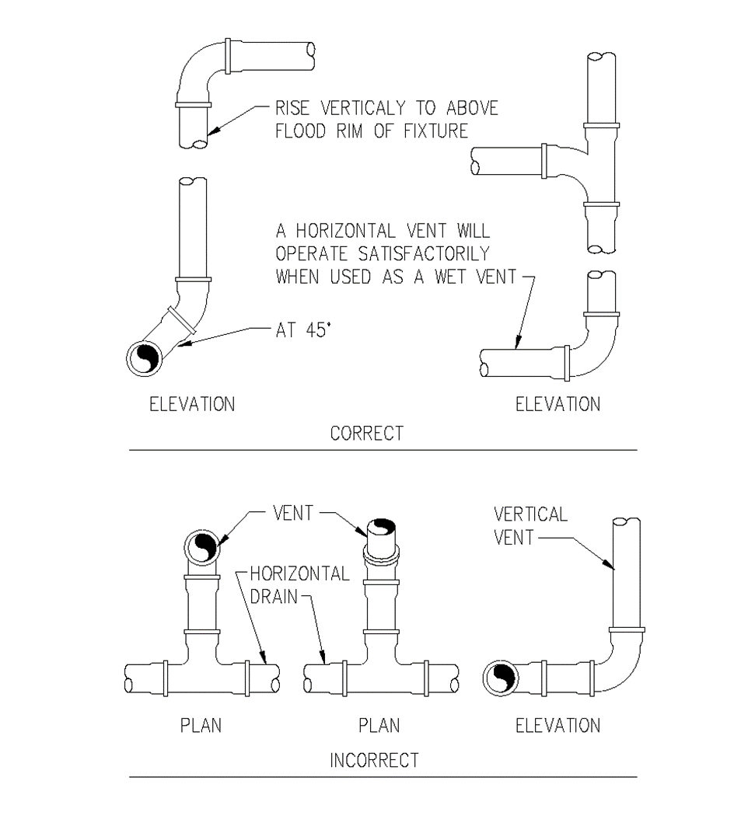

(Source: Amended at 38 Ill. Reg. 9940, effective April 24, 2014)

**Section 890.APPENDIX K Illustrations for Subpart K**

**Section 890.ILLUSTRATION BB Fixtures Back-to-Back in Battery**

(Referenced in Section 890.1520(d))

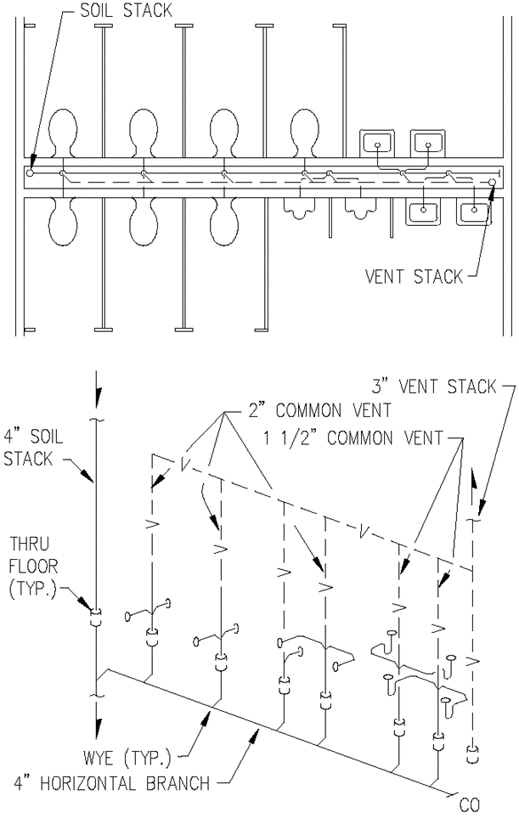

(Source: Amended at 38 Ill. Reg. 9940, effective April 24, 2014)

**Section 890.APPENDIX K Illustrations for Subpart K**

**Section 890.ILLUSTRATION CC Fixture Connections-Offset Vents**

(Referenced in Sections 890.1520(e) & 890.1550(a))

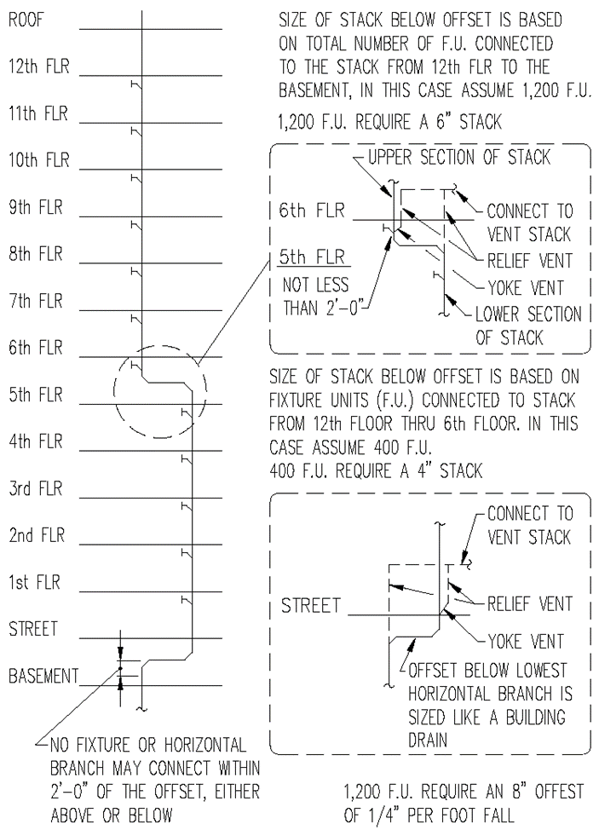

(Source: Amended at 38 Ill. Reg. 9940, effective April 24, 2014)

**Section 890.APPENDIX K Illustrations for Subpart K**

**Section 890.ILLUSTRATION DD Circuit Vented Fixtures**

(Referenced in Section 890.1520(f))

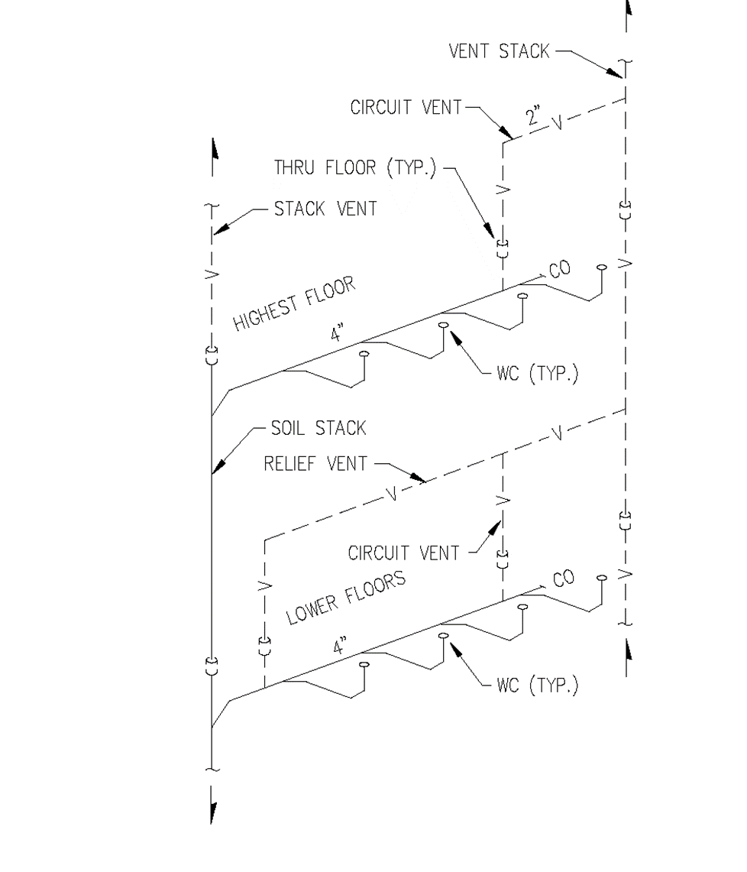

(Source: Amended at 38 Ill. Reg. 9940, effective April 24, 2014)

**Section 890.APPENDIX K Illustrations for Subpart K**

**Section 890.ILLUSTRATION EE Vent Stacks**

(Referenced in Section 890.1450(e))

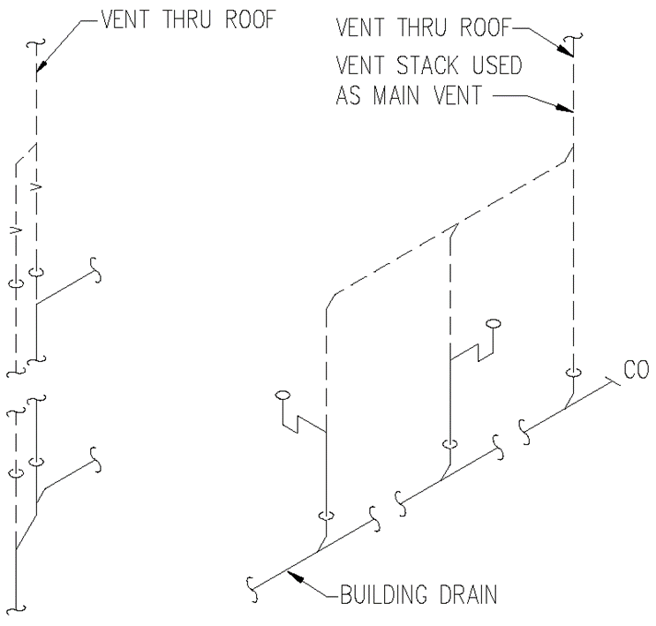

(Source: Amended at 38 Ill. Reg. 9940, effective April 24, 2014)

**Section 890.APPENDIX K Illustrations for Subpart K**

**Section 890.ILLUSTRATION FF Combination Waste and Vent**

(Referenced in Section 890.1590(d))

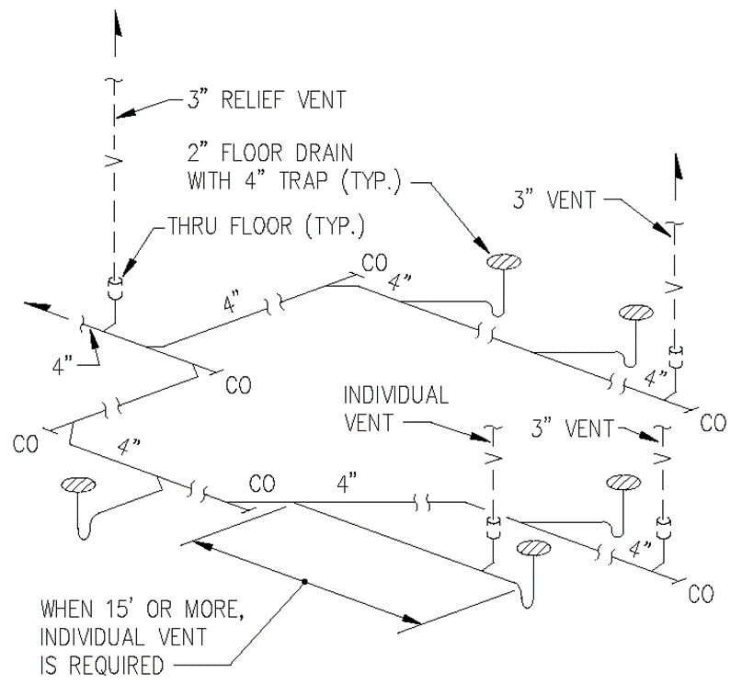

(Source: Amended at 38 Ill. Reg. 9940, effective April 24, 2014)

**Section 890.APPENDIX K Illustrations for Subpart K**

**Section 890.ILLUSTRATION GG Special Venting for Island Fixtures**

(Referenced in Section 890.1600(b))

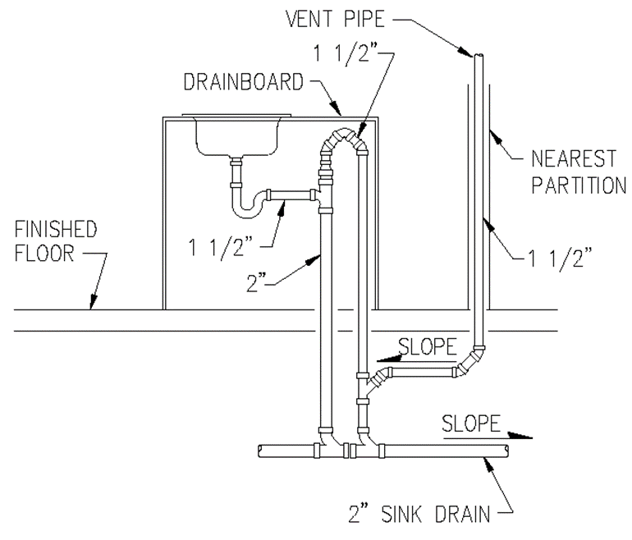

(Source: Amended at 38 Ill. Reg. 9940, effective April 24, 2014)