**Section 890.APPENDIX K Illustrations for Subpart K**

**Section 890.ILLUSTRATION H Height Above Fixtures**

(Referenced in Section 890.1450(c))

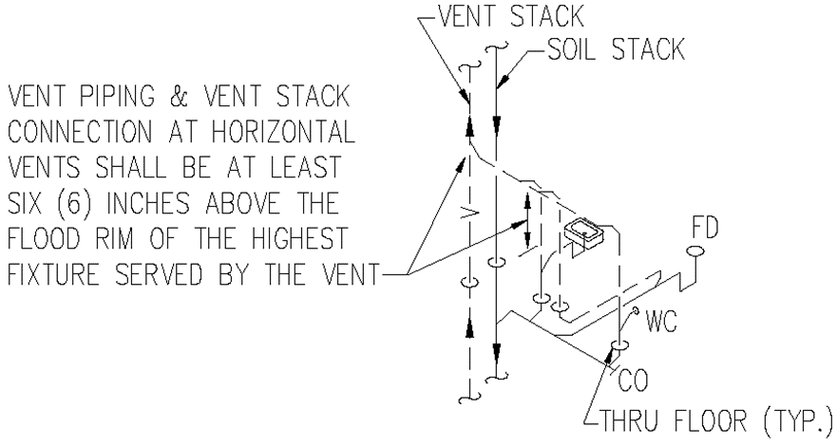

(Source: Amended at 38 Ill. Reg. 9940, effective April 24, 2014)