**Section 890.APPENDIX E Illustrations for Subpart E**

**Section 890.ILLUSTRATION C Interceptor/Separator Vents**

(Referenced in Section 890.510(a)(6))

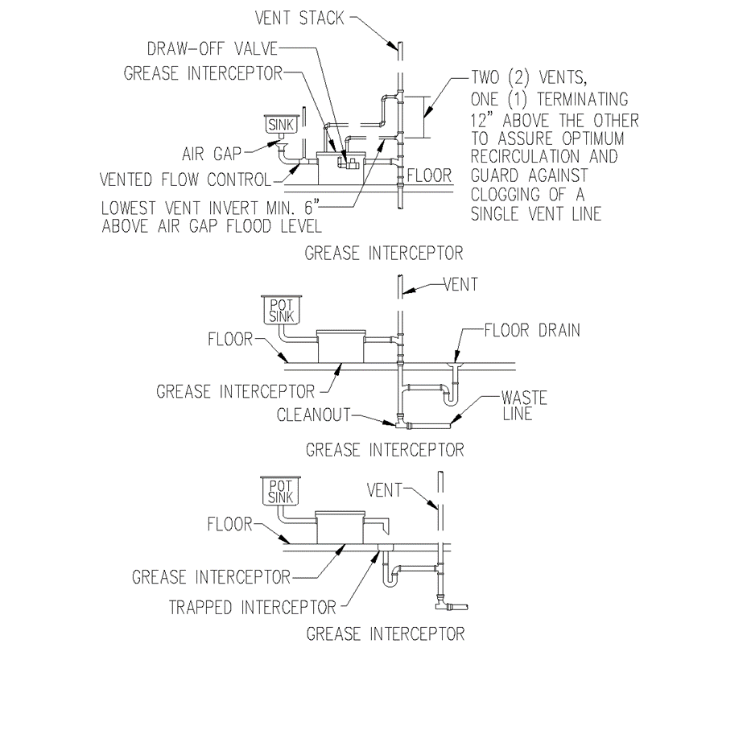

(Source: Amended at 38 Ill. Reg. 9940, effective April 24, 2014)