**Section 890.APPENDIX B Illustrations for Subpart A**

**Section 890.ILLUSTRATION I Common Vent**

(Referenced in Section 890.120, Definition of "Common Vent.")

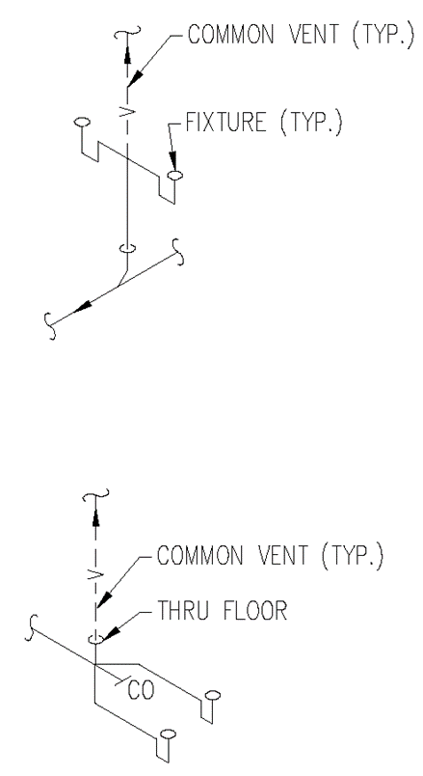

(Source: Amended at 38 Ill. Reg. 9940, effective April 24, 2014)