**Section 820.APPENDIX A Illustrations**

**Section 820.ILLUSTRATION B Pool Walls**

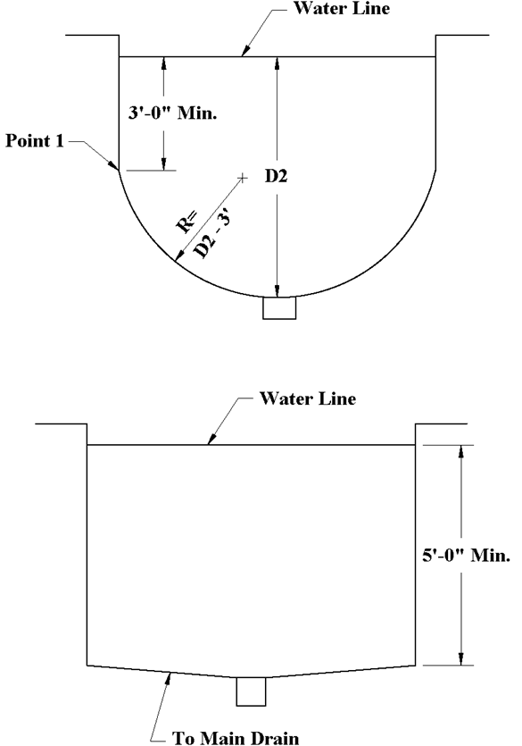

(Source: Amended at 37 Ill. Reg. 16539, effective October 4, 2013)