Section 400.ILLUSTRATION D "$100 Fine" Sign

ILLINOIS STANDARD
R7-I101
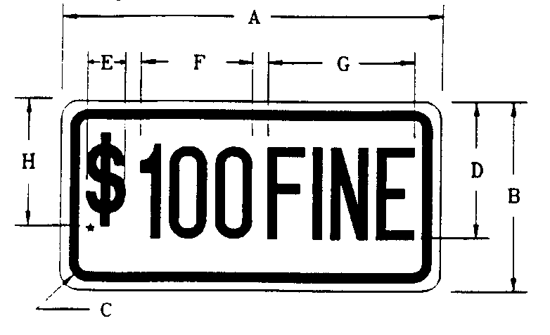

COLOR LEGEND AND BORDER | GREEN NON-REFLECTORIZED
BACKGROUND | WHITE REFLECTORIZED

SIGN SIZE | DIMENSIONS
 | A | B | C | D | E | F | G | H
6 X 12 | 12.0 | 6.0 | 1.5 | 4.5 | 1.15 | 3.4 | 4.6 | 4.0

SIGN SIZE | SERIES | MARGEN | BORDER | BLK STD.
 | TIMES
 | 7
6 X 12 | 3A | 0.37 | 0.37 | B5-126

All Dimensions in Inches
To be used with R7-8
*$=Series 3A "s"

