Section 1515.EXHIBIT A Map of Eligible Area in Illinois and Kaskaskia River Watersheds

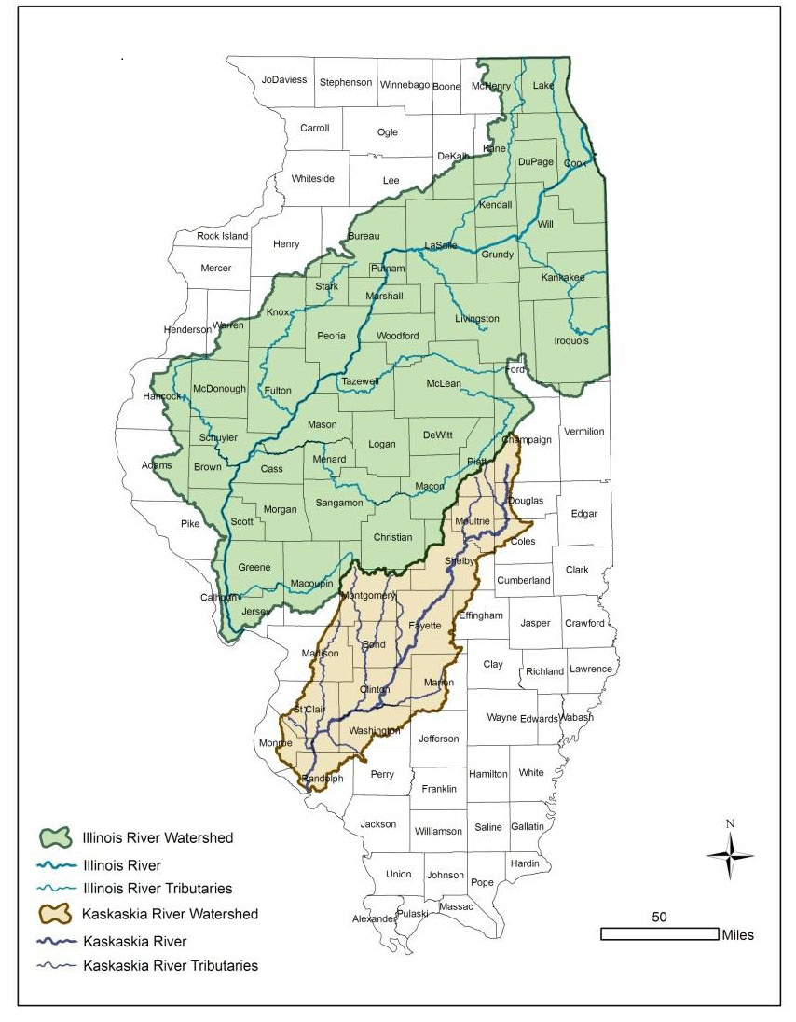

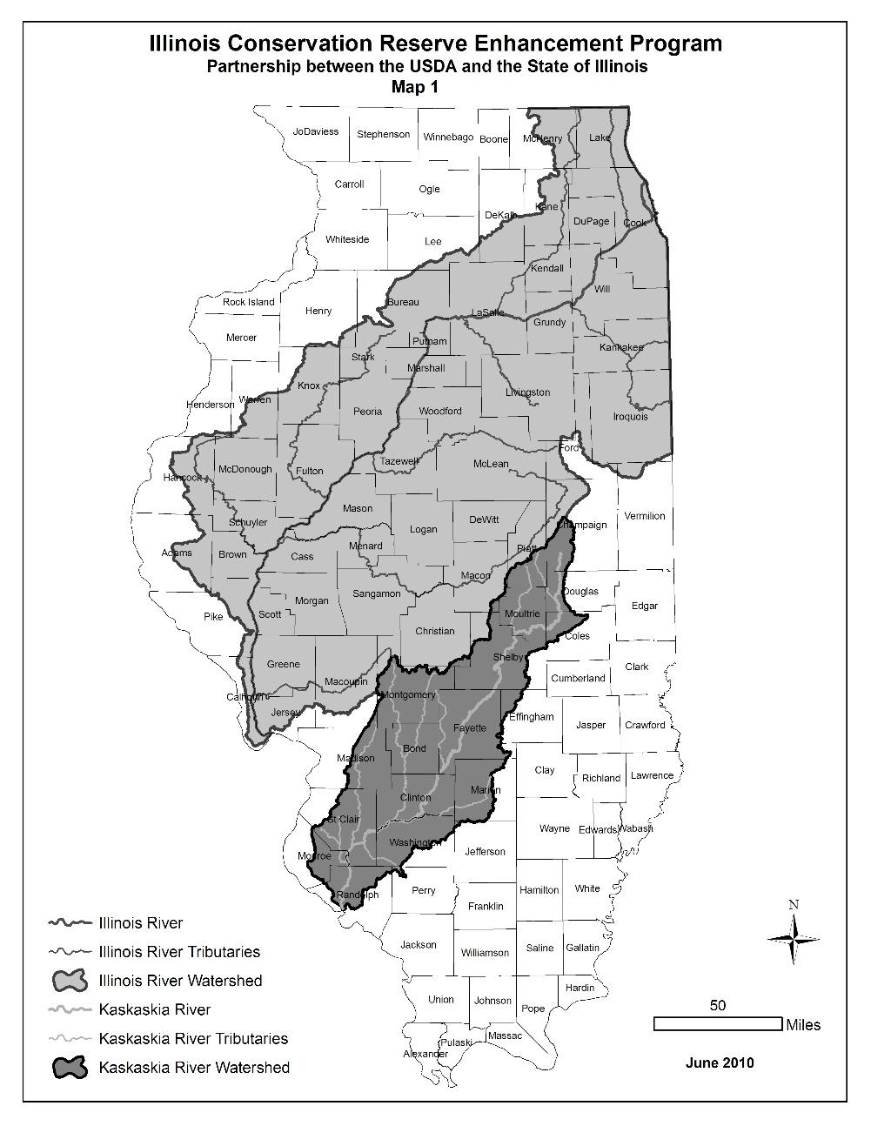

(Source: Amended at 46 Ill. Reg. 5986, effective March 30, 2022)

