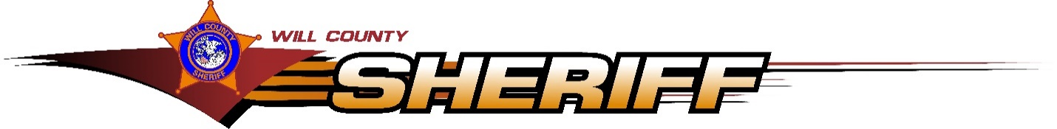

May 5, 2020

To Whom It May Concern,

This letter is in regards to the reports that are required from the Will County Sheriff’s Department for grant monies that were awarded for body cameras and/or in-car cameras in 2018. Due to the covid-19 pandemic many of our staff are currently off and this is putting a delay on retrieving all the information for this annual report.  We were able to get some of our employees in to complete this task, but we were not be able to make the May 1st deadline.  My apologies for any issues this may cause.

Very Respectfully,

**Sgt. Kyle Lakomiak**

***Traffic Division***

***Will County Sheriff’s Police***

*16911 W. Laraway Rd*

*Suite 101*

*Joliet, Il 60433*

*Office: (815)727-3263*

*Fax:      (815)774-6289*

WILL COUNTY SHERIFF - LOGO