December 28, 2020

The Honorable JB Pritzker
Governor
State of Illinois
207 State House
Springfield, IL 62706

Dear Governor Pritzker:
Enclosed is a copy of the Treasurer’s 2020 Annual Report as required by Section 15 of the State Treasurer Act, Section 3(a) of the State Finance Act and Article V, Section 19 of the Illinois Constitution. This report can also be found on the treasurer’s website at www.illinoistreasurer.gov.

Sincerely,
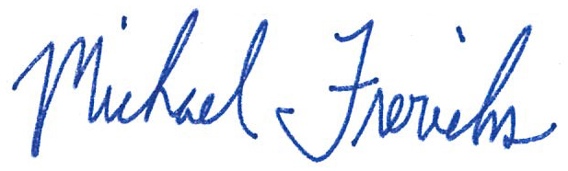

Michael W. Frerichs
Illinois State Treasurer

