Office of the Kane County State’s Attorney

JAMIE L. MOSSER
State’s Attorney
Kane County Judicial Center General Offices:
37W777 Route 38 Suite 300 (630) 232-3500
St. Charles, Illinois 60175

March 3, 2021

Mr. John W. Hollman
Clerk of the House
300 State House
Springfield, IL 62706

Re: Annual Lead Paint Poisoning Report to the General Assembly

Dear Mr. Hollman:

Please allow this to serve as the Kane County State’s Attorney’s report to the General Assembly pursuant to 410 ILCS 45/12.1. The Kane County Department of Health, a delegate of the Department of Health and Human Services, did not refer any lead poisoning cases for enforcement from January 1, 2020 through December 31, 2020.

Sincerely,

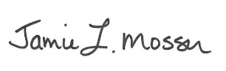

Jamie L. Mosser
Kane County State’s Attorney

